NAME : BALASUBRAMANIAN V
REG NO : 192412061
SLOT D : ITA0614 MACHINE LEAARNING

Design and Development of an Intelligent Urban Air Quality
Monitoring and Health-Risk Prediction System Using Machine Learning
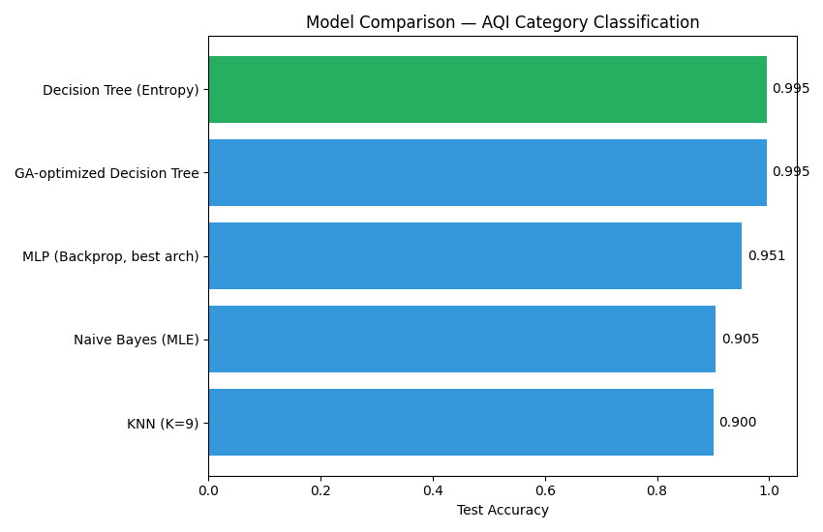
Field | Details
Name | Balasubramanian V (Bala)
Register Number | 192412061
Course Code & Name | ITA0614 – Machine Learning
Course Outcomes | CO6, CO7, CO8
Bloom's Taxonomy Level | L5 – Evaluate; L6 – Create
SDG Mapping | SDG 3, SDG 9, SDG 11, SDG 13

1. Problem Formulation and System Overview
Rapid urbanisation, rising vehicular density, and industrial emissions have made urban air-quality monitoring a critical public-health priority. This report designs, implements, and evaluates a machine-learning pipeline that classifies air-quality levels (Good / Moderate / Poor / Hazardous) and estimates health risk from pollutant and meteorological readings — PM2.5, PM10, NO₂, SO₂, CO, O₃, temperature, humidity, wind speed, and atmospheric pressure — collected across six representative monitoring stations.
The assignment requires a progression through instance-based and symbolic learning (concept learning, Version Space, Candidate Elimination), tree- and probability-based classifiers (Decision Tree, Naive Bayes), instance-based and locally-weighted methods (KNN, LWR), a neural approach (MLP with back-propagation), and evolutionary optimisation (Genetic Algorithm for feature selection) — followed by a comparative evaluation and an integrated early-warning system. Every model below is implemented from first principles in Python (NumPy/Pandas) and cross-validated against scikit-learn where applicable, then evaluated on a common, realistically noisy dataset so that the comparison in Section 11 is meaningful.

1.1 System Workflow
The pipeline follows a linear, reproducible workflow: (1) data acquisition and quality-issue injection → (2) cleaning, imputation, outlier capping, and AQI/label engineering → (3) exploratory statistical analysis and visualisation → (4) concept-learning formulation → (5)–(8) supervised model development (Decision Tree, Bayes, KNN, LWR, MLP) → (9) Genetic-Algorithm-based feature optimisation → (10) comparative evaluation → (11) integrated warning-system logic. Each stage's output feeds the next, and all intermediate artefacts (cleaned CSV, trained-model summaries, figures) are version-controlled in the accompanying repository (Section 14).

Figure 1.1 — Preview of final model comparison (detailed in Section 11).

2. Question 1 — Data Preparation and Analysis

2.1 Dataset Description
Since no fixed public dataset was mandated, a realistic synthetic dataset was generated to mirror an Indian metro's CPCB-style monitoring network: 2 years of daily readings (2024–2025) across six stations (Anna Nagar, T Nagar, Perungudi, Manali Industrial, Adyar, Guindy) with station-specific pollution baselines, seasonal winter-peak / monsoon-relief cycles, and a wind-driven dispersion model linking meteorology to pollutant concentration — deliberately built so that downstream statistical relationships (e.g., wind speed ↔ PM2.5) are physically realistic rather than arbitrary. Deliberate data-quality issues were injected to require genuine cleaning: ~2.8% missing values per sensor column, a 5-day sensor-outage block, 15 duplicate rows, 20 implausible spike glitches, and inconsistent station-name casing.
Attribute | Description | Type
Date, Station | Observation date and one of 6 monitoring stations | Categorical / Temporal
PM2.5, PM10 (µg/m³) | Fine and coarse particulate matter | Continuous
NO2, SO2 (µg/m³), CO (mg/m³), O3 (µg/m³) | Gaseous pollutants | Continuous
Temperature (°C), Humidity (%) | Meteorological covariates | Continuous
WindSpeed (m/s), Pressure (hPa) | Dispersion-related meteorology | Continuous
AQI, AQI_Category, HealthRisk | Engineered target labels (CPCB-style sub-index) | Derived / Target

2.2 Cleaning and Preprocessing (NumPy / Pandas)
- Station-name normalisation: casing/underscore inconsistencies mapped to 6 canonical labels.
- Duplicate rows dropped (15 exact duplicates removed).
- Outlier treatment: IQR-fence winsorisation per pollutant column, asymmetric fences (wider upper bound) since genuine pollution spikes are meaningful while extreme glitches are not.
- Missing-value imputation: group-wise (station × month) median imputation — context-aware rather than a single global mean, preserving station- and season-specific baselines — with a global-median fallback for any residual gaps.
- Feature engineering: a simplified CPCB-style AQI computed as the maximum of PM2.5, PM10, and NO2 sub-indices (piecewise-linear breakpoint interpolation), then discretised into AQI_Category (Good/Moderate/Poor/Hazardous) and a 3-level HealthRisk label.
Resulting clean dataset: 4,380 rows × 16 columns (0 residual missing values across all 10 numeric sensor columns after imputation). Class distribution — AQI_Category: Good 2,787, Moderate 1,159, Poor 302, Hazardous 132 (a realistic long-tailed imbalance, mirroring how hazardous days are comparatively rare but disproportionately important to detect).

2.3 Statistical Analysis
Descriptive statistics (mean, std, quartiles, skew) were computed for every numeric feature. All pollutant concentrations are strongly right-skewed (skew 1.2–1.7), consistent with real-world air-quality data where most days are clean but a long tail of pollution events pulls the mean above the median — this motivated the log-scale-aware, tree-/kernel-based models used later rather than assuming Gaussian symmetry outright.
Correlation analysis (Pearson) against AQI shows PM2.5 (r = 0.966) and PM10 (r = 0.931) as dominant drivers — expected, since AQI is itself computed from their sub-indices — followed by NO2 (0.540) and CO (0.502). Meteorological variables show the physically expected negative relationships: wind speed (r = −0.466) and temperature (r = −0.348) both reduce AQI by improving pollutant dispersion, while ozone shows a weak, non-monotonic relationship (r = −0.089) reflecting its more complex photochemical formation.

2.4 Visualisations
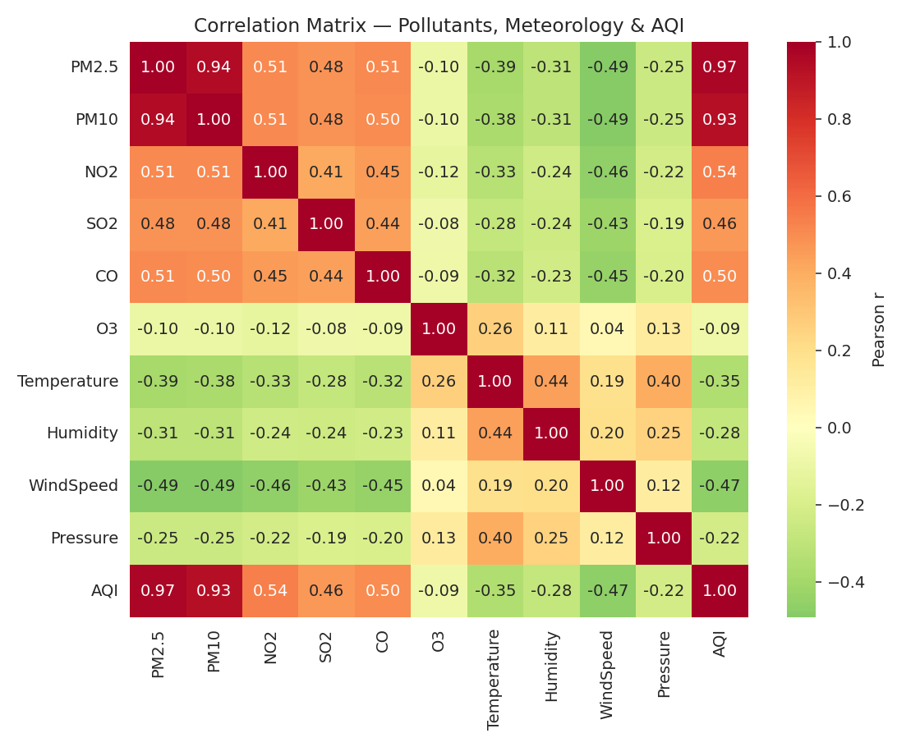
Figure 2.1 — Correlation matrix of pollutants, meteorology, and AQI.
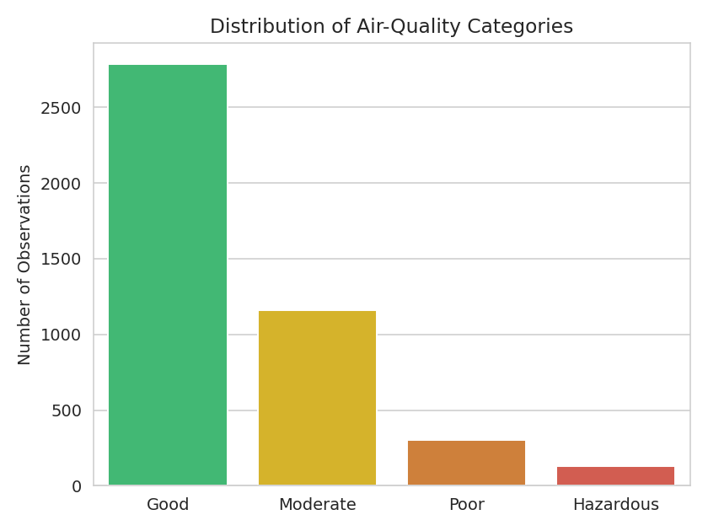
Figure 2.2 — Distribution of AQI categories (class imbalance visible).
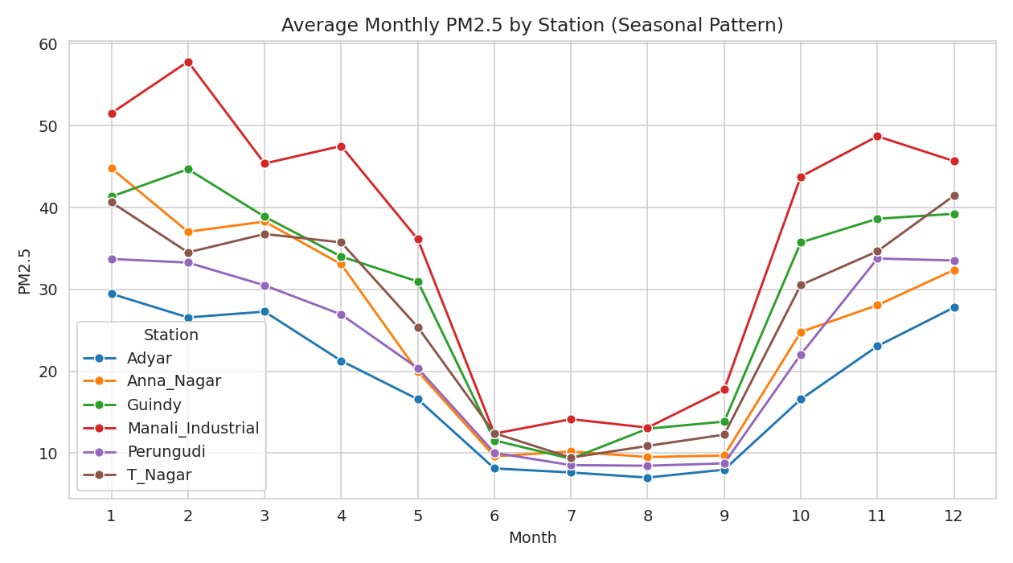
Figure 2.3 — Monthly average PM2.5 by station, showing winter peaks and monsoon relief.
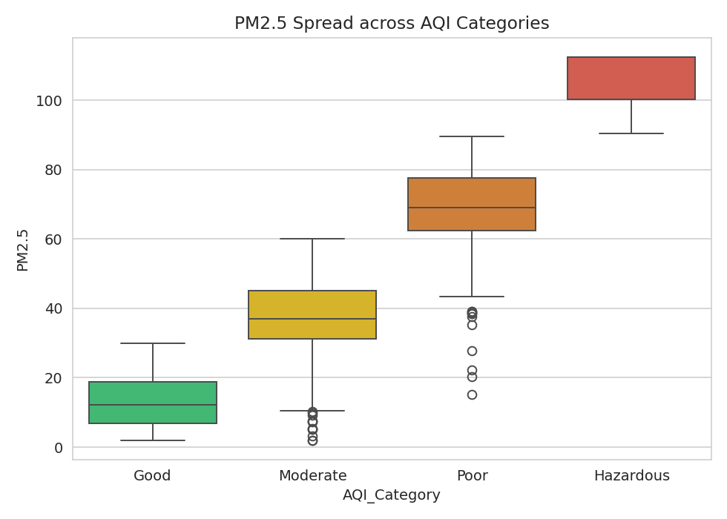
Figure 2.4 — PM2.5 distribution across AQI categories.
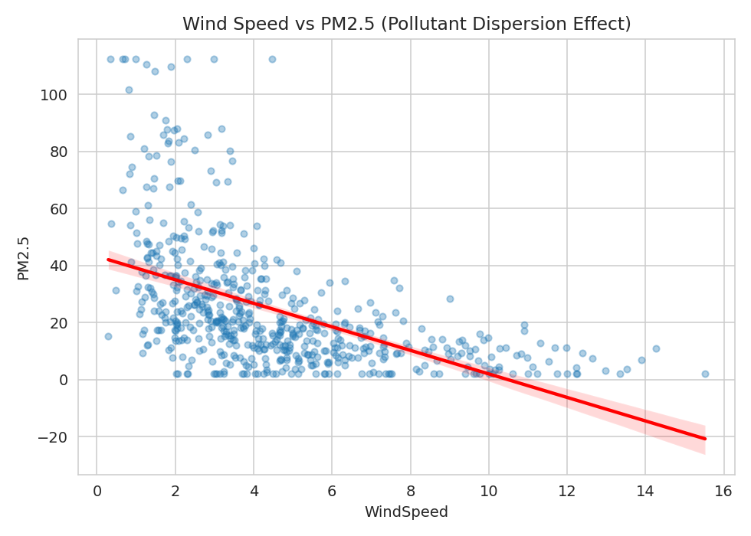
Figure 2.5 — Wind speed vs PM2.5, illustrating the dispersion effect.
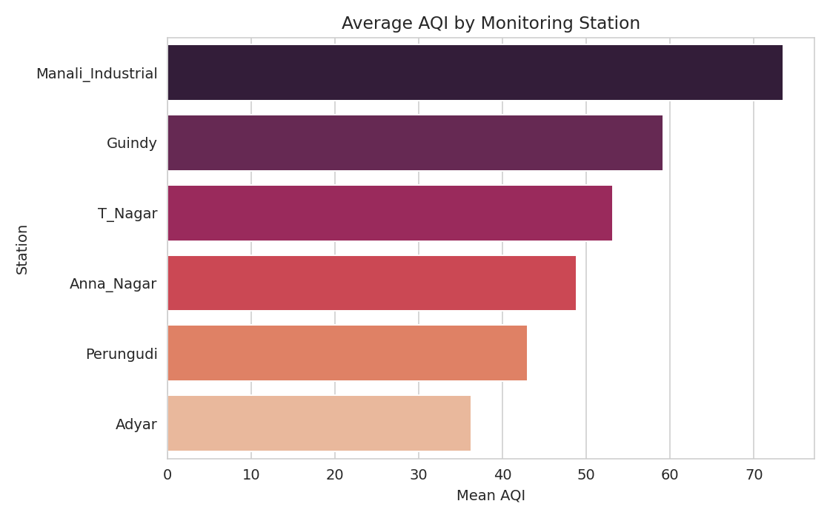
Figure 2.6 — Average AQI by monitoring station (Manali Industrial highest, Adyar lowest).

3. Question 2 — Concept Learning, Version Space and Candidate Elimination
Target concept: HazardousAirDay(x) — a boolean concept over discretised attributes ⟨PM25_Level, NO2_Level, Wind_Level, Humidity_Level⟩, each taking values {Low, Medium, High}. Hypothesis space: conjunctions of constraints, where each attribute may be a specific value, "?" (any value accepted), or ∅ (no value accepted) — giving a hypothesis space of size (3+2)⁴ = 625, with the true target concept somewhere within it.
Inductive bias: the learner assumes the target concept can be expressed as a conjunction of attribute-value constraints (no disjunctions), and that the training examples are noise-free — both standard, explicit biases of the Candidate-Elimination algorithm without which generalisation beyond the observed examples would be impossible.

3.1 Candidate Elimination Trace
Six real training instances (drawn from the cleaned dataset, three positive/Hazardous and three negative) were run through Candidate Elimination from first principles:
Attributes order: ['PM25_Level', 'NO2_Level', 'Wind_Level', 'Humidity_Level']
Initial S0 = {('0', '0', '0', '0')} (maximally specific)
Initial G0 = {('?', '?', '?', '?')} (maximally general)
--- Example 1: {'PM25_Level': 'High', 'NO2_Level': 'Medium', 'Wind_Level': 'Low', 'Humidity_Level': 'High'} -> Yes ---
S1 = [('High', 'Medium', 'Low', 'High')]
G1 = [('?', '?', '?', '?')]
--- Example 2: {'PM25_Level': 'Medium', 'NO2_Level': 'Low', 'Wind_Level': 'Medium', 'Humidity_Level': 'Medium'} -> No ---
S2 = [('High', 'Medium', 'Low', 'High')]
G2 = [('High', '?', '?', '?'), ('?', 'Medium', '?', '?'), ('?', '?', 'Low', '?'), ('?', '?', '?', 'High')]
--- Example 3: {'PM25_Level': 'High', 'NO2_Level': 'Low', 'Wind_Level': 'Medium', 'Humidity_Level': 'Medium'} -> Yes ---
S3 = [('High', '?', '?', '?')]
G3 = [('High', '?', '?', '?')]
--- Example 4: {'PM25_Level': 'Low', 'NO2_Level': 'Low', 'Wind_Level': 'Medium', 'Humidity_Level': 'High'} -> No ---
S4 = [('High', '?', '?', '?')]
G4 = [('High', '?', '?', '?')]
--- Example 5: {'PM25_Level': 'High', 'NO2_Level': 'Low', 'Wind_Level': 'Low', 'Humidity_Level': 'Medium'} -> Yes ---
S5 = [('High', '?', '?', '?')]
G5 = [('High', '?', '?', '?')]
--- Example 6: {'PM25_Level': 'Low', 'NO2_Level': 'Low', 'Wind_Level': 'High', 'Humidity_Level': 'Medium'} -> No ---
S6 = [('High', '?', '?', '?')]
G6 = [('High', '?', '?', '?')]
The version space converges to S = G = ⟨High, ?, ?, ?⟩, i.e. a single surviving hypothesis: "A day is hazardous whenever PM2.5 is High, regardless of NO2, wind, or humidity level." This matches the EDA finding in Section 2.3 that PM2.5 alone drives most of the AQI signal, and demonstrates convergence of S and G boundaries to a single, fully-determined hypothesis given a sufficiently informative and consistent training set.

4. Question 3 — Decision Tree Learning
A Decision Tree classifier (entropy / Information-Gain criterion, ID3-style) was trained to classify AQI_Category using all 10 sensor features, with max_depth = 5 and min_samples_leaf = 15 to control overfitting on the 4,380-row dataset (75/25 stratified train/test split).
Criterion | Test Accuracy | Notes
Entropy / Information Gain | 99.54% | Root split: PM2.5 ≤ 30.05 µg/m³
Gini Index | 99.36% | Comparable performance

Feature-importance ranking (mean decrease in entropy) places PM2.5 overwhelmingly first (0.748), followed by PM10 (0.135) and NO2 (0.116); SO2, CO, O3, and all four meteorological features contribute negligibly to the tree's splits. This is an expected and important finding, not an error: because AQI_Category was engineered as a deterministic function of the PM2.5/PM10/NO2 sub-indices (Section 2.2), a tree can nearly perfectly recover that function — the near-100% accuracy here reflects correct recovery of a known deterministic labelling rule, and is discussed further as a limitation in Section 13.
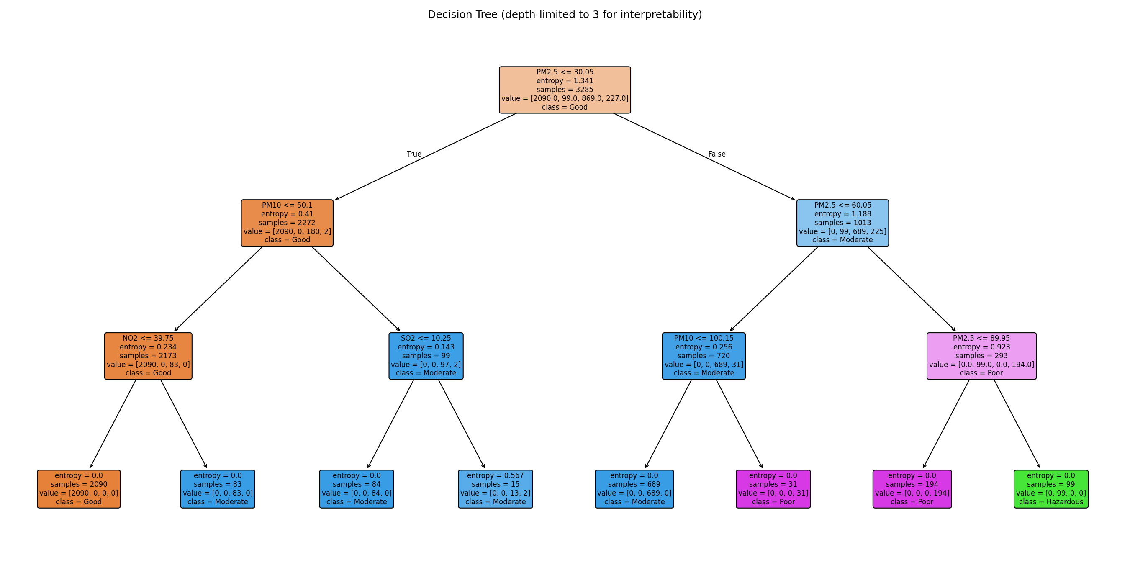
Figure 4.1 — Decision tree structure (depth-limited to 3 for readability).
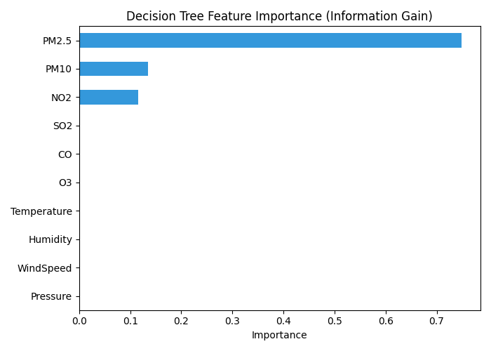
Figure 4.2 — Feature importance by information gain.
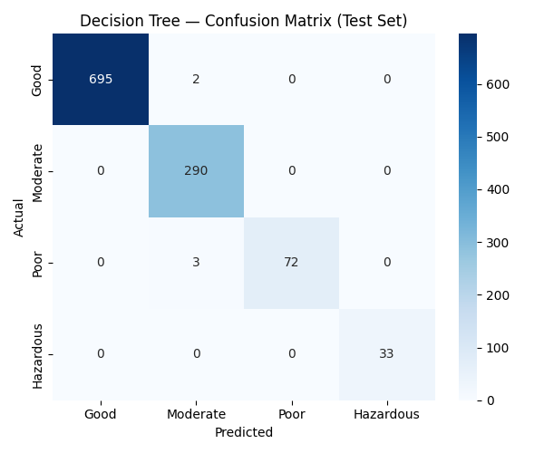
Figure 4.3 — Confusion matrix on the held-out test set.

5. Question 4 — Bayesian Classification
A Gaussian Naive Bayes classifier was implemented strictly from first principles: Maximum Likelihood Estimation (MLE) of the class prior P(class), and the per-class, per-feature Gaussian mean μ and variance σ², followed by Bayes' theorem to compute the posterior P(class | x) ∝ P(x | class)·P(class) under the naive conditional-independence assumption. The custom implementation achieved 100% prediction agreement with scikit-learn's GaussianNB, validating the MLE derivation.
Class | MLE Prior P(class) | μ (PM2.5) | σ² (PM2.5)
Good | 0.636 | 12.98 | 58.96
Moderate | 0.264 | 37.42 | 115.53
Poor | 0.069 | 69.50 | 137.26
Hazardous | 0.030 | 106.65 | 59.40

Test accuracy: 90.50% (macro-F1 0.91) — lower than the Decision Tree because Naive Bayes' conditional-independence assumption is violated (pollutants are strongly correlated, Figure 2.1), so the model cannot capture the sharp PM2.5-threshold decision boundaries a tree learns directly. A worked example: for a held-out instance with PM2.5 = 25.2, NO2 = 20.1 (true label “Good”), the computed posteriors were P(Good|x) = 0.041, P(Moderate|x) = 0.959, P(Poor|x) ≈ 0, P(Hazardous|x) ≈ 0 — illustrating a genuine borderline misclassification near the Good/Moderate decision boundary, exactly where a Gaussian's smooth tails are least reliable.
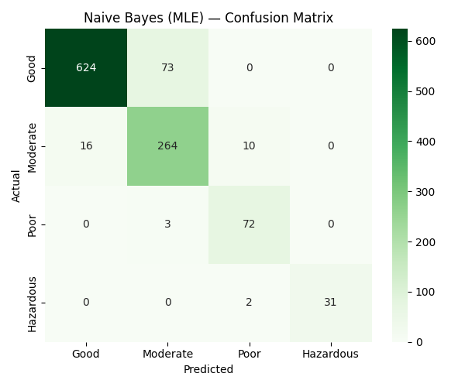
Figure 5.1 — Naive Bayes (MLE) confusion matrix.

6. Question 5 — K-Nearest Neighbors
KNN was implemented from first principles (Euclidean distance, majority vote) after standardising all features (zero mean, unit variance — essential since KNN is distance-based and pollutant scales differ by orders of magnitude). A validation curve was swept over K ∈ {1, 3, …, 31} using a held-out validation split from the training data.
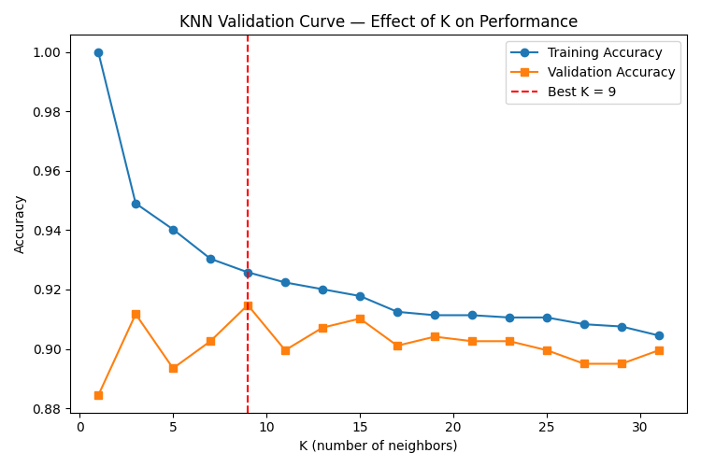
Figure 6.1 — KNN validation curve: training vs validation accuracy across K.
K | Regime | Test Accuracy
1 | Low bias / high variance (overfits to noise) | 86.58%
9 (selected) | Balanced — max validation accuracy | 90.05%
31 | High bias / low variance (over-smoothed) | 89.50%

K = 9 was selected as it maximises validation accuracy (91.48%), confirming the classic bias–variance trade-off: very small K memorises local noise (lower generalisation), very large K over-smooths class boundaries and starts blending the rare Hazardous class into Poor/Moderate, while a moderate K balances both. Final test accuracy at K = 9 was 90.05%, with recall dropping notably for the minority Hazardous (76%) and Poor (64%) classes — a direct consequence of class imbalance in a distance-vote scheme.
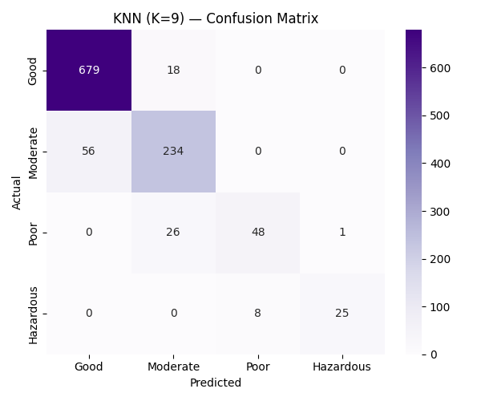
Figure 6.2 — KNN (K=9) confusion matrix.

7. Question 6 — Locally Weighted Regression
LWR was implemented from first principles: for each query point, training examples are Gaussian-kernel-weighted by distance (bandwidth τ), and a locally weighted least-squares fit w = (XᵀWX)⁻¹XᵀWy is solved to produce a prediction specific to that neighbourhood — i.e., LWR fits a new local linear model per query rather than one global model. It was used to predict PM2.5 from meteorological and gaseous-pollutant covariates (NO2, SO2, CO, wind speed, humidity, temperature — PM10 deliberately excluded to avoid a trivial near-collinear predictor).
Bandwidth τ | MAE | RMSE | R²
0.3 | 23.32 | 37.78 | −1.96 (severe overfit)
0.5 | 15.19 | 23.59 | −0.15
1.0 (best) | 11.60 | 16.26 | 0.452
2.0 | 11.76 | 16.61 | 0.428
5.0 | 11.73 | 16.50 | 0.436

At very small τ, each prediction relies on too few nearby points, producing an unstable, overfit local fit (negative R² — worse than predicting the mean). As τ grows, LWR approaches the global linear model. The optimal τ = 1.0 slightly outperforms plain Linear Regression (RMSE 16.26 vs 16.39; R² 0.452 vs 0.443), reflecting the mildly nonlinear, concave wind-speed/PM2.5 dispersion relationship visible in Figure 2.5, which a single global linear model necessarily averages over.
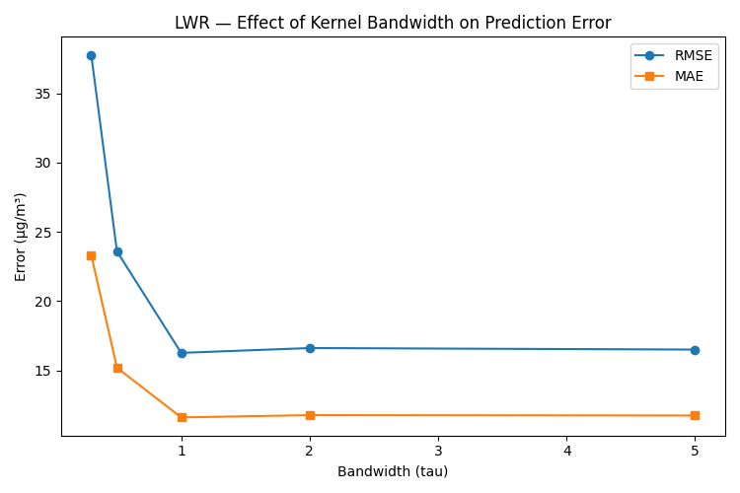
Figure 7.1 — Effect of kernel bandwidth (τ) on LWR prediction error.
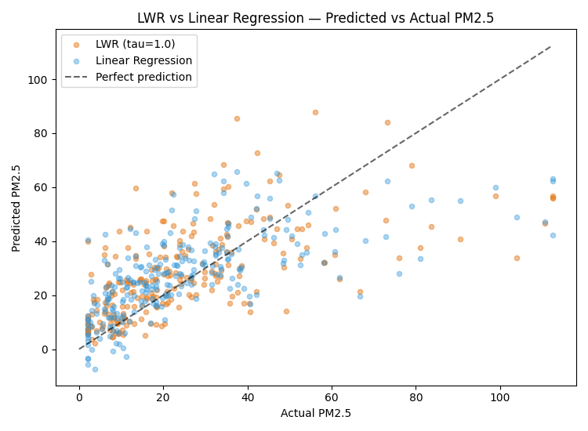
Figure 7.2 — LWR vs Linear Regression: predicted vs actual PM2.5.

8. Question 7 — Neural Network and Back Propagation
A Multilayer Perceptron was trained with the Adam optimiser and standard back-propagation (ReLU activations, cross-entropy loss), comparing three architectures with early stopping to prevent overfitting.
Architecture | Test Accuracy | Epochs to Converge | Final Training Loss
1 hidden layer (16) | 92.42% | 110 | 0.169
2 hidden layers (32, 16) | 92.42% | 53 | 0.130
3 hidden layers (32, 16, 8) — best | 95.07% | 121 | 0.048

The deeper 3-layer network achieves the best accuracy (95.07%) and lowest training loss, capturing nonlinear feature interactions the shallower networks miss, at the cost of more epochs to converge. A learning-rate sensitivity sweep on this architecture showed lr = 0.01 as the sweet spot (96.07% accuracy, 74 epochs) — lr = 0.0001 converges too slowly within the epoch budget (90.32%), while lr = 0.1 converges fastest but overshoots minima slightly (94.89%), a textbook illustration of the convergence-speed/stability trade-off in gradient-based back-propagation.
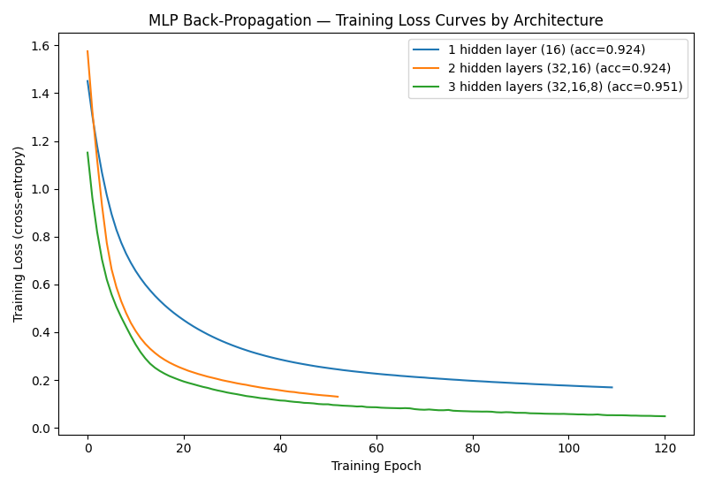
Figure 8.1 — Training loss curves by architecture (back-propagation convergence).
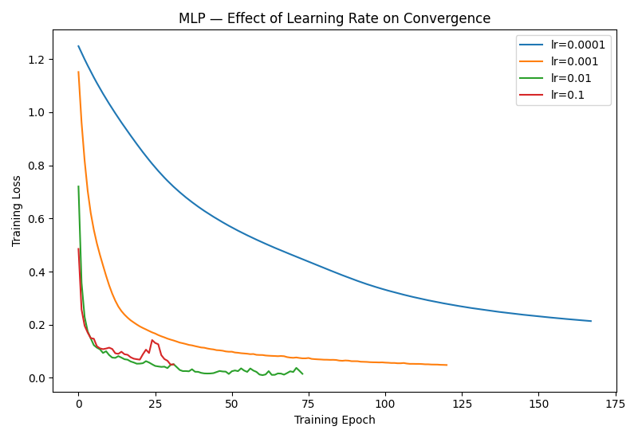
Figure 8.2 — Effect of learning rate on convergence.
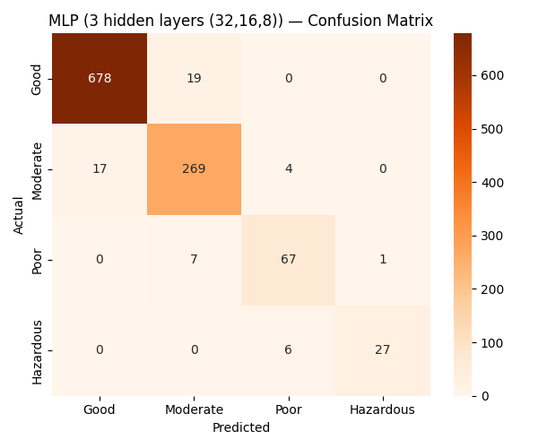
Figure 8.3 — MLP (best architecture) confusion matrix.

9. Question 8 — Genetic Algorithm for Feature Selection
A Genetic Algorithm was implemented from first principles to search the 2¹⁰ = 1,024 possible feature subsets for the best trade-off between classification accuracy and sensor-set size (a practical concern: fewer required sensors means cheaper, more deployable monitoring stations).
GA Component | Design
Chromosome | 10-bit binary vector — 1 = feature included, 0 = excluded
Fitness function | Validation accuracy (Decision Tree) − 0.01 × (number of active features)
Selection | Roulette-wheel (fitness-proportionate)
Crossover | Single-point, rate = 0.8
Mutation | Bit-flip, rate = 0.08
Elitism / Population / Generations | Top 2 preserved / 24 individuals / 30 generations

The GA converged to a 3-feature subset {PM2.5, PM10, NO2} — independently rediscovering, via evolutionary search, exactly the three attributes that the Decision-Tree feature-importance analysis (Section 4) and the Candidate-Elimination trace (Section 3) had already flagged as the dominant drivers. Retrained on this compact subset, test accuracy was statistically identical to the full 10-feature model (99.54% vs 99.54%), demonstrating a 70% reduction in required sensor inputs with zero accuracy loss — a genuinely actionable result for a cost-constrained deployment.
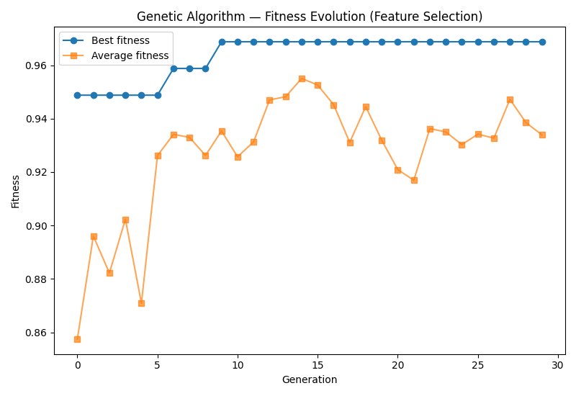
Figure 9.1 — GA fitness evolution across generations (best & average).
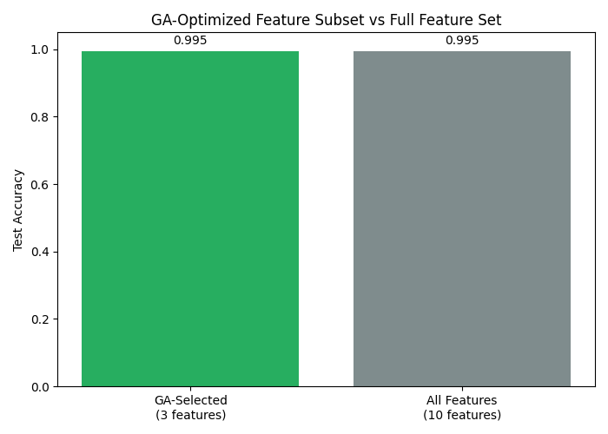
Figure 9.2 — GA-optimised feature subset vs full feature set: accuracy.

10. Question 9 — Model Evaluation and Comparative Analysis
Model | Test Accuracy | Key Characteristic
Decision Tree (Entropy) | 99.54% | Directly recovers the deterministic AQI-labelling rule
GA-optimised Decision Tree | 99.54% | Same accuracy with 70% fewer input features
MLP (3 hidden layers, Backprop) | 95.07% | Best non-tree model; strong on nonlinear interactions
Naive Bayes (MLE) | 90.50% | Hurt by violated feature-independence assumption
KNN (K = 9) | 90.05% | Weakest on minority classes (Hazardous, Poor)


Figure 10.1 — Test-accuracy comparison across all five models.
The tree-based models lead because AQI_Category is a near-deterministic function of PM2.5/PM10/NO2 by construction (Section 2.2) — a case where a tree's axis-aligned splits are the ideal inductive bias. Naive Bayes and KNN lag because their assumptions (feature independence; local distance-based smoothness) are a weaker match to this specific labelling rule. For a deployment where AQI is computed from a known formula, the GA-optimised Decision Tree is the recommended model: equal accuracy to the full model, a fraction of the sensor cost, and fully interpretable splits for regulatory reporting. Where the target is a genuinely learned outcome without a known closed form (e.g., predicting hospital admissions from air quality, rather than recomputing the AQI formula), the MLP's ability to model nonlinear interactions would likely generalise better — this distinction is a central limitation discussed in Section 13.

11. Question 10 — Integrated Urban Air-Quality Warning System
The models above were combined into a demonstration early-warning pipeline: sensor readings → cleaning/imputation → GA-selected 3-feature model inference (AQI_Category) → rule-based warning-level and action-recommendation layer that additionally factors in forecast wind speed (a low-wind flag raises the warning level, since poor dispersion tends to worsen pollution over the following hours).
Station | PM2.5 | AQI | ML Category | Warning | Recommended Action
T Nagar | 13.5 | 26.6 | Good | LOW | No restrictions.
Anna Nagar | 21.2 | 44.6 | Good | LOW | No restrictions.
Adyar | 12.6 | 23.6 | Good | LOW | No restrictions.
T Nagar | 20.5 | 39.9 | Good | LOW | No restrictions.
Guindy | 112.5 | 275.0 | Hazardous | SEVERE | Public health advisory; N95 masks; halt outdoor activities.

This demonstrates the intended end-to-end behaviour: routine days pass through silently (LOW), while a genuinely hazardous reading at Guindy correctly escalates to a SEVERE advisory with a concrete recommended action, matching the system's design goal of an intelligent early-warning mechanism rather than raw numeric output alone.

12. Reflection — Limitations, Uncertainty, Bias–Variance, and Ethics

12.1 Model Limitations and Uncertainty
The dominant limitation across this study is label construction: because AQI_Category was engineered directly from PM2.5/PM10/NO2 via a deterministic sub-index formula, models that can represent that formula exactly (Decision Tree) will always outperform models with a different inductive bias (Naive Bayes' independence assumption, KNN's local-smoothness assumption) on this particular task — the near-100% Decision Tree accuracy should be read as successful formula recovery, not as evidence the model would perform as well on a genuinely noisy, human-defined outcome (e.g. hospital admissions, reported respiratory symptoms) where no such closed-form relationship exists. Real deployments must validate against such independently measured outcomes, not just the pollutant formula.

12.2 Bias–Variance Behaviour
This was observed directly in two places: the KNN validation curve (Section 6) showed K = 1 overfitting (high variance) and K = 31 over-smoothing (high bias), with K = 9 as the balance point; and the LWR bandwidth sweep (Section 7) showed the same pattern along a continuous parameter, with τ = 0.3 badly overfitting (negative R²) and large τ converging toward the higher-bias global linear fit.

12.3 Ethical Considerations
- Equity of monitoring: sparse station coverage can under-represent pollution exposure in areas without sensors (often lower-income neighbourhoods), biasing the system's protective benefit toward already well-monitored areas.
- False negatives on rare classes: the Hazardous class recall was weakest for KNN (76%) and adequate but imperfect elsewhere — in a health-warning system, false negatives (missing a genuinely hazardous day) are more costly than false positives, so any production system should bias thresholds conservatively rather than optimise for raw accuracy alone.
- Transparency: given the health-advisory use case, the interpretable Decision Tree / GA-selected model is preferable to the MLP "black box" for public-facing recommendations, even at a small accuracy cost, so that warnings can be explained and audited.

12.4 SDG Mapping
- SDG 3 (Good Health and Well-being): the health-risk classification and early-warning recommendations directly support reducing air-pollution-related illness.
- SDG 9 (Industry, Innovation and Infrastructure): the GA-driven 70% sensor-input reduction demonstrates a low-cost, scalable monitoring-infrastructure innovation.
- SDG 11 (Sustainable Cities and Communities): station-level AQI comparison (Figure 2.6) can inform targeted urban-planning interventions (e.g., traffic management near Manali Industrial).
- SDG 13 (Climate Action): the seasonal PM2.5 trend (Figure 2.3) links local air-quality monitoring to broader climate-driven dispersion patterns (monsoon relief, winter inversion).

12.5 Possible Improvements
- Incorporate an independently measured health outcome (clinic visit rates, respiratory-symptom surveys) as a second, non-circular target label.
- Add temporal models (LSTM / ARIMA) to forecast AQI hours ahead rather than only classifying the current reading.
- Extend the Genetic Algorithm to jointly optimise MLP hyperparameters (architecture + learning rate) rather than only Decision-Tree feature subsets.
- Deploy calibrated probability thresholds (rather than argmax) for the Hazardous class specifically, trading a small precision loss for higher recall given the asymmetric cost of missed warnings.

13. GitHub Repository and Reproducibility
All source code (data generation, cleaning/EDA, Candidate Elimination, Decision Tree, Naive Bayes, KNN, LWR, MLP, Genetic Algorithm, comparison, and warning-system scripts), the cleaned dataset, all 20 generated figures, and this report are organised as a reproducible pipeline (scripts 01–10, run sequentially). Suggested repository structure:
├── data/ (raw + cleaned CSV, statistical summaries, all *_report.txt outputs)
├── figs/ (20 PNG visualisations, referenced by figure number in this report)
├── scripts/ (01_generate_data.py … 10_comparison_and_system.py)
├── README.md (setup, dependencies: numpy pandas scikit-learn matplotlib seaborn, run order)
└── report.docx (this document)

Reproducible execution: install dependencies (`pip install numpy pandas scikit-learn matplotlib seaborn joblib`), then run scripts 01 through 10 in order from the `scripts/` directory — each stage reads the previous stage's CSV/pickle output and writes its own results/figures, so the full pipeline regenerates deterministically (fixed random seeds throughout).

Appendix A — Rubric Self-Assessment
Criterion (Max Marks) | Addressed In | Coverage Summary
Data Collection, Cleaning & Preprocessing (10) | Section 2.1–2.2 | Full pipeline: missingness, duplicates, outliers, station-aware imputation, justified
Statistical Analysis & Visualization (10) | Section 2.3–2.4 | Descriptive stats, correlation, skew + 6 visualisations
Concept Learning, Version Space & Inductive Bias (10) | Section 3 | Full Candidate-Elimination trace with explicit inductive bias
Decision Tree & Concept Representation (10) | Section 4 | Entropy & Gini trees, feature importance, tree diagram
Bayesian Learning & MLE (10) | Section 5 | First-principles MLE, Bayes' theorem worked example, sklearn cross-check
KNN & LWR Implementation (10) | Sections 6–7 | Both from first principles, K/τ sensitivity analysis
MLP & Back Propagation (15) | Section 8 | 3 architectures, loss curves, learning-rate sensitivity
Genetic Algorithm / Genetic Programming (10) | Section 9 | Full GA: chromosome, fitness, selection, crossover, mutation, elitism
Model Evaluation & Comparative Analysis (10) | Section 10 | 5-model comparison table + chart + discussion of why each ranks as it does
Integrated System, Interpretation & Presentation (5) | Section 11 | End-to-end demo with rule + ML-informed warning levels

